**Name:** EVORA, GIOLO M.  
**Year and Course:** 4 – F2  
**Topic:** The Rise of Artificial Intelligence: Transforming Industries and Job Opportunities  
**Speaker:** Engr. Patrick Kendrex L. Lucero  
 Mr. Gary Lloyd Senoc  
 Mr. Richard M. Badlisan  
 Ms. Armiely Obinguar  
 Mr. Dennis Franco M. Layug  
**Date and Time:** November 24, 2023; 7:00 AM – 5:00 PM **Venue:** Seminar atDivine Word College of Calapan Gymnasium

**I. Introduction**

The **"5th MIMAROPA IT Congress"** is a major conference in the MIMAROPA region focused on Information Technology. It gathers IT professionals, experts, professors, and students to explore the theme "The Rise of Artificial Intelligence (AI): Transforming Industries and Job Opportunities." The seminar delves into the impact of AI on the IT landscape, discussing its implications for businesses, society, job opportunities, education, and the evolving role of AI in shaping the future of technology.

**II. Narration and Events**

On November 24, 2023, at 7 am, we attended the 5th MIMAROPA IT Congress at DWCC Gymnasium. The theme was "The Rise of Artificial Intelligence: Transforming Industries and Job Opportunities." The event brought together IT professionals, experts, professors, and students from different schools. The program, starting with registration and the main program at 8 am, featured keynote speaker Dir. Cheryl C. Ortega, who shared valuable insights on the theme.

The seminar included five technical session speakers using Microsoft PowerPoint. Engr. Patrick Kendrex L. Lucero discussed "Artificial Intelligence in Industry 4.0," emphasizing AI's pivotal role and practical applications. Mr. Gary Lloyd Senoc talked about "Emerging Technologies and Job Disruption in AI," highlighting ethical aspects and dispelling myths about AI taking over jobs.

Ms. Armielyn Obinguar addressed "Ethical and Legal Considerations in AI," emphasizing the importance of privacy rights and ethical standards. Mr. Richard M. Badlisan shared insights on "Startups and Innovation in AI," focusing on user-centric design and data-driven decision-making. Mr. Dennis Franco M. Layug discussed "Artificial Intelligence in Education," showcasing innovations like Kevin the robot and the Ray-Ban smart glass.

The event featured intermission performances, Q&A, and raffle draws. Overall, it provided diverse insights on AI's transformative influence in various industries and job opportunities, making it a well-organized and valuable exploration of AI's impact.

**III. Knowledge / Learning Acquired**

The 5th MIMAROPA IT Congress broadened my understanding of Artificial Intelligence (AI). Key takeaways include the importance of addressing ethical concerns such as fairness and privacy. I now recognize AI as a tool to complement human efforts, fostering collaboration rather than replacement. Continuous learning is crucial, given AI's dynamic evolution over time. As Mr. Layug emphasized, "AI holds the promise of a brighter future."

**IV. Observation**

The seminar showcased diverse expertise among the speakers, offering detailed perspectives on Artificial Intelligence. Kudos to the DWCC facilitating teams for their excellent accommodation and approach. The impressive performances by the artists added excitement and enhanced attendee participation. Overall, it was a well-organized and successful event.

**V. Recommendations / Suggestions**

I have no recommendations as the entire program of the 5th MIMAROPA IT Congress was excellent. I enjoyed my time as a participant, and the facilitators and organizing team did a commendable job. They were accommodating and easily accessible for any event-related queries.

**VI. Certificate** (To follow)

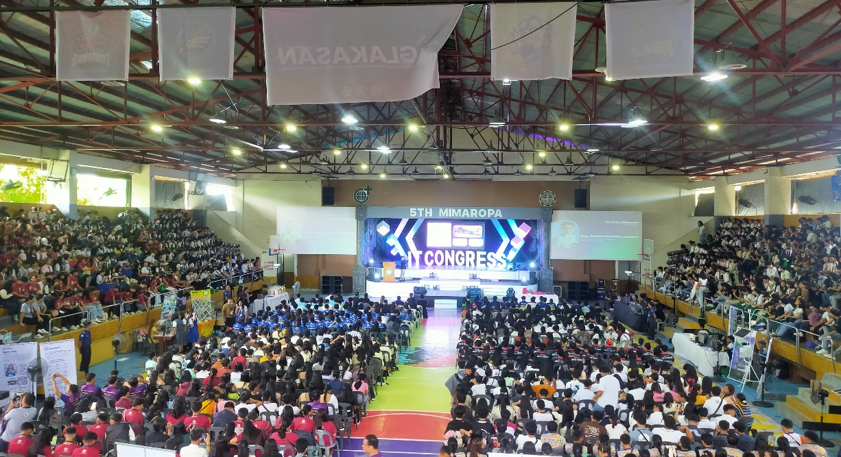**VII. Screenshots**

**Name:** EVORA, GIOLO M.  
**Year and Course:** 4 – F2  
**Topic:** Empower360: A Blueprint for Personal Development   
**Speaker:** Ms. Pauline C. Cual  
**Date and Time:** December 01, 2023; 8:00 AM – 9:00 AM **Venue:** MinSU Calapan Campus - Library

**I. Introduction**

**"Empower360: A Blueprint for Personal Development"** is a seminar offering a holistic guide to enhance personal growth and well-being. It empowers participants with insights into self-concept, stress management, and the journey towards self-acceptance or improvement. The goal is to provide practical tools and strategies for positive life changes, resilience building, and cultivating a healthy mindset.

**II. Narration and Events**

On December 1, 2023, I participated in the "Empower360: A Blueprint for Personal Development" webinar at MinSU Calapan Campus - Library from 8:00 AM to 9:00 AM, featuring Ms. Pauline Cual as the guest speaker. The event aimed to guide participants in personal development, covering self-concept, stress management, and the journey towards self-acceptance or improvement.

The webinar started with a prayer at 8:49 AM, followed by the national anthem and MinSU hymn. Opening remarks highlighted the importance of investing in personal growth. Dean John Edgar Anthony delivered an inspirational message, framing the seminar as a canvas for self-improvement.

An intermission by John Kevin De Leon added a lively dance movement before the guest speaker, Ms. Pauline C. Cual, took the stage. Her insightful talk focused on leaving one's comfort zone, cultivating a holistic personality, and the impact of thoughts on personal development. Stress management strategies were discussed through engaging activities like BINGO.

The session concluded with valuable takeaways, encouraging participants to distinguish social and real self-images, providing stress management tips, and promoting thoughtful career growth planning.

**III. Knowledge / Learning Acquired**

In this empowering session, I acquired deep insights into self-concept awareness, recognizing the importance of aligning our ideal and actual selves. The stress management activities, notably the BINGO exercise, provided practical tools to identify stress triggers and enhance emotional well-being. Valuable tips on time management, self-care, and assertiveness were particularly enlightening.

**IV. Observation**

The "Empower360" session provided profound insights into self-concept, stress management, and valuable tips for well-being, making it an enriching and empowering experience.

**V. Recommendations / Suggestions**

I highly recommend attending "Empower360" for valuable insights into personal development, stress management, and practical tips for well-being. It's an empowering session with enriching takeaways.

**VI. Certificate** (To follow)

**VII. Screenshots**

